NOT FOR IMMEDIATE RELEASE – EMBARGOED UNTIL 6:00 pm, Thursday October 17th, 2024

Toronto Metropolitan University Students Showcase 3D Design Talent in Little Canada’s Little West Coast Exhibit
Collaboration highlights the innovative spirit of Little Canada and The University, showcasing the skills of students and the stunning attention to detail that Little Canada is known for.
Toronto, ON – October 2024
Toronto Metropolitan University (TMU) is thrilled to announce the results of their successful collaboration with one of Toronto's award-winning tourist attractions, Little Canada. Students from TMU's 3D Printing class, offered through the Graphic Communications Management department, had the unique opportunity to design a variety of "real-life" objects that were then 3D printed, finished and featured in Little Canada's newest destination: Little West Coast, unveiling on October 17th, 2024.

Little Canada tells unique and untold stories of Canada and showcases the richness & diversity of the country’s cities and landscapes through the art of miniature. Little Canada is renowned for its scale replicas of natural and man-made structures throughout Canada. The new West Coast exhibit highlights famous landmarks and everyday scenes from that region of the country, all meticulously designed and detailed – with more than 20,000 person-hours of labour contributing to its fantastic scenes, structures and environments.

Student Contributions to the Little Canada West Coast Exhibit
The 3D Printing course, run by TMU instructor Lee Eldridge, covers 3D Design and modeling, scanning, software, and various 3D printing technologies. As part of this collaboration, students had the opportunity to create 3D designs ranging from iconic landmarks such as the Japanese Canadian War Memorial in Stanley Park, Vancouver, to some of the everyday details that make Little Canada’s scenes so realistic, such as fire hydrants and patio umbrellas.

Student designed items were printed using advanced stereolithography (SLA) 3D printers, which use liquid resin and UV lights to print incredibly detailed small-scale models. The printed models were then painted and prepared by Little Canada's incredibly skilled details team, ensuring that each piece seamlessly integrates into the exhibit.

"This project has been an incredible opportunity for our students to apply their skills to a real-world project and contribute something that millions of people will see. Seeing their designs featured in such a well-loved venue is a testament to their hard work and creativity. The Little Canada team has been amazingly supportive every step of the way, making it an incredibly rewarding experience for everyone involved!”
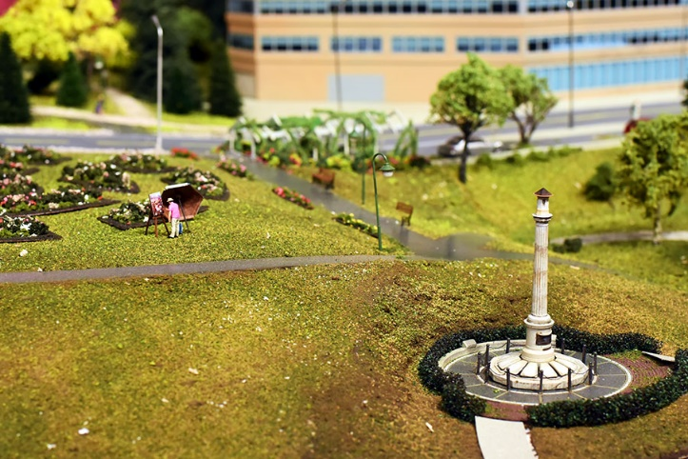
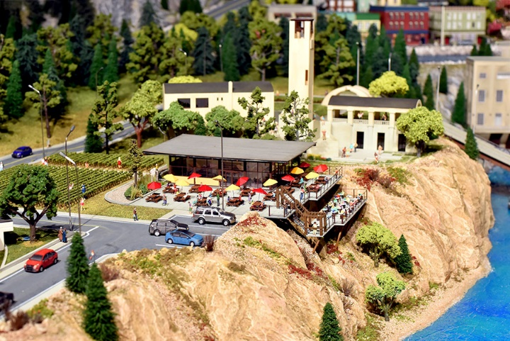
Lee Eldridge, Toronto Metropolitan University
(Formerly Ryerson University)
Images for publication available at GraphicEd.org/littlecanada

"Partnering with Lee and his students has been a wonderful collaboration all around. Being able to help enhance their skills, and then bring their creations to life is incredibly rewarding for the whole team here at Little Canada. We’re proud to showcase their talent and look forward to future collaborations with the university!”
Jessica Garcia,
Leader, Destinations
Little Canada
About Little Canada
Little Canada is one of the most popular tourist destinations in Toronto, voted #1 attraction in Ontario by Trip Advisor in 2024 and #1 Top Indoor Attraction for the last 3 consecutive years by Attractions Ontario. It offers guests an incredible miniature yet highly detailed view of Canada's iconic land and cityscapes. The attraction is located right downtown near Yonge and Dundas Square, making it easily accessible for locals and tourists alike.
For more information about Little Canada, visit: www.little-canada.ca.
About Toronto Metropolitan University (formerly Ryerson University)
Located in the heart of downtown Toronto, Toronto Metropolitan University (TMU) is a leading institution known for its innovation and research in various fields. TMU is committed to providing students with hands-on learning experiences that prepare them for successful careers in their chosen industries.

Images Available
For images to use alongside your posts or articles, please access our press image assets at: https://GraphicEd.org/littlecanada

Interviews & Follow-Up
For additional information, images, or to arrange an interview with the instructor about the project
or about 3D printing processes, please contact:

Lee Eldridge
Instructor, Graphic Communications Management & Creative Industries
Toronto Metropolitan University
Lee.Eldridge@TorontoMU.ca
416-573-3553

For information from Little Canada Directly, please contact:

Jessica Garcia
Leader, Destinations
Little Canada
jessicag@little-canada.ca

For any other details, please contact Jill Sans via email at Jill@GraphicEd.org

Contact: Jill Sans Media Relations

Source: Graphic Education – GraphicEd.org

NOT FOR IMMEDIATE RELEASE – EMBARGOED UNTIL 6:00 pm, Thursday October 17th, 2024
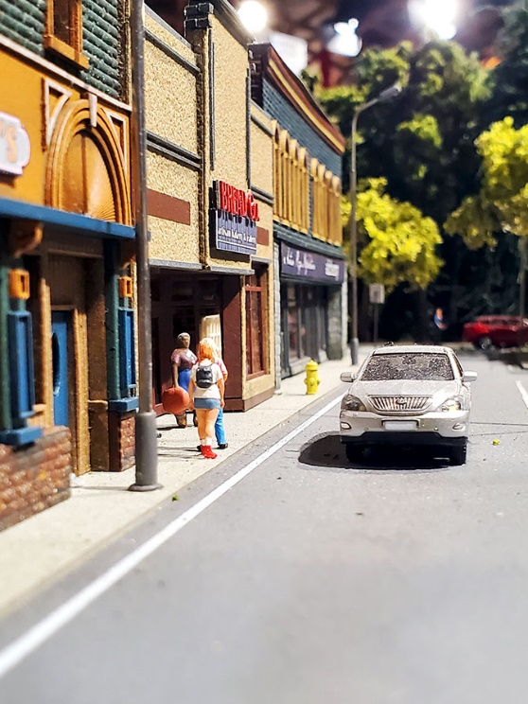
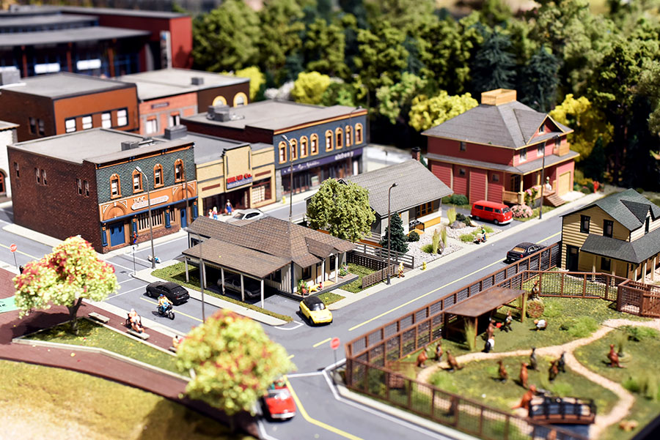
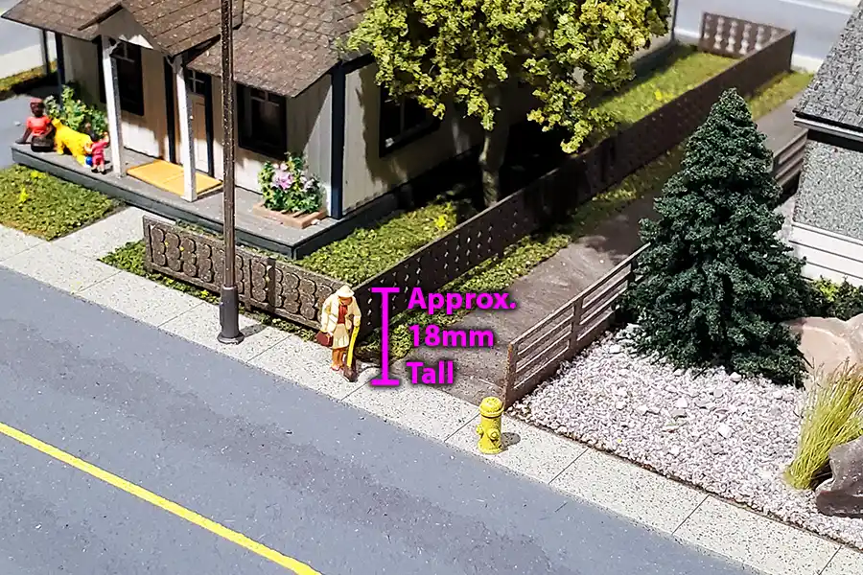
Images for publication available at GraphicEd.org/littlecanada

